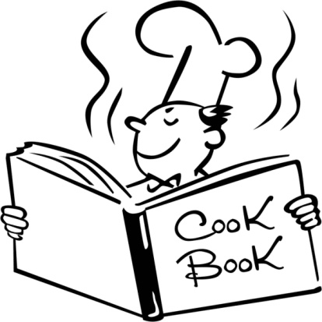
Springville High
FOOD AND NUTRITION 1
Mrs. Keller — Room C-17
Best way to contact me: hannah.keller@nebo.edu
Website: http://mrskellerfacs.weebly.com

Course Description: This course is designed to focus on the science of food and nutrition. Experiences will include food safety and sanitation, culinary technology, food preparation and dietary analysis to develop a healthy life style with pathways to career readiness. Laboratory based experiences strengthen comprehension of concepts and standards outlined to Sciences, Technology, Engineering and Math (STEM) education. FCCLA may be an integral part of this course.

Course Objectives: When students complete this course, they will be proficient in the following standards:
- Consistently demonstrate kitchen safety procedures and sanitation techniques.
- Apply the skills of kitchen equipment and management.
- Identify the sources and functions of carbohydrates and fiver and apply appropriate and food preparation techniques.
- Identify the sources and functions of proteins and lipids (fats and oils) and apply appropriate food preparation techniques.
- Identify the sources and functions of select vitamins, minerals and water and apply appropriate food preparation techniques to foods high in these nutrients.
- Explore the current Dietary Guidelines and ChooseMyPlate.gov.

Classroom Expectations: Along with the following classroom expectations, students will be expected to follow all school rules and dress code. Students will:
1. Be on time: School tardiness policy will be followed. A daily “Bell-Ringer” will be given.
– Tardy or absent students will NOT be able to make up these points!
2. Be prepared: Students will need a pen or pencil every day.
3. BE RESPECTFUL: Students will show respect for others, the equipment, and myself.
4. FOLLOW DIRECTIONS!
5. Keep hands, feet, and other objects to yourself.
6. Treat others kindly. Bullying will not be tolerated in my classroom. All reports of bullying will be reported to the administration.

Consequences: 1st- verbal warning. 2nd- Lose participation points, move seat.
3rd- Parent notification, lose participation points. 4th- Removal from class, see administration.

Lab Rules: In order for our class to have the privilege to cook, all lab rules are expected
to be followed. Students will:
1. Stay in assigned kitchens or at assigned table.
2. Keep the noise level low.
3. Complete assigned cooking and cleaning jobs.
4. Act responsibly: No horseplay (snapping towels, splashing water, wandering, etc.).
5. Keep hands and other objects to yourself.
6. Respect all equipment and use it appropriately.

Consequences: 1st: Verbal warning. 2nd: Five points taken from lab grade. 3rd: All lab points taken, parent notification. 4th: Cooking privilege taken away, parent notification.

Grades: Grades will include an average of daily participation points, in class assignments, cooking labs, and homework. Cooking labs will be worth 30 points each. Students and parents may check all class grades by going to the schools website, www.shs.nebo.edu, and accessing the SIS login link.

Grading Scale:
100-93% = A 86-83% = B 76-73% = C 66 – 63% = D
92-90% = A- 82-80% = B- 72-70% = C- 62 – 60% = D-
89-87% = B+ 79-77% = C+ 69-67% = D+ 59 – 0% = F

Homework: There is a minimal amount of homework in this class. However, if a student does not finish the work in class, it will be assigned as homework.

Attendance: SHS attendance policies will be enforced. Attendance is crucial for this course. If a student is absent they will be required to make up the work that they missed. Students are responsible to find out what they missed and what they need to do to make up the work. Attendance is also 10% of a student’s grade.

Make-up: If students miss a lab, they must make the same recipe that they missed in class at home. They will then return the “Lab Make-up” sheet to me with a parent/guardian signature along with a sample or picture of the food item made. If you bring a picture you have to be in the picture with the food!

Dress and Grooming: Students will be expected to follow proper food safety and sanitation procedures which includes proper dress and grooming. During labs students will be expected to have their hair pulled back, and wear closed toe shoes. Students will be informed in advance of upcoming labs via the class website and/or the calendar posted in the classroom, so that they will be prepared. Students who come to class unprepared will lose points from their lab score.

Electronic Devices: School policy will be enforced for electronic devices. See the “Electronic Devices” section in the student handbook for more details.

Foods I: Mrs. Keller Period: ______

PLEASE SIGN AND RETURN

Student Name (please print)_______________________________________________________

Student Signature_____________________________________________________ (I have read
the disclosure and am willing to follow the rules and procedures for Foods).

Parent/Guardian Signature______________________________________________ (I have read the disclosure with my student and understand the expectations of my student in Foods).

Does your student have any FOOD ALLERGIES? Please explain.

- If you would be willing to share or teach any skills, talents or knowledge with our class, please explain below. For example, if you have a recipe you love and would like to demonstrate for the class, if you own a food business and would like to share any experiences or demonstrate a recipe, etc. We would love to have parent involvement in our classroom!

__________________________________________________________________________________________________________________________________________________________________________________________________________________________________________
______________________________________________________________________________
______________________________________________________________________________

THANK YOU!

