QUICK PIZZA BENDER/CALZONES

2 Rhodes dinner rolls (per person), thawed
¼ cup pizza or spaghetti sauce
2 Tbs. toppings (mushrooms, green peppers, pepperoni, onions, olives, etc.)
¼ cup grated mozzarella cheese
Butter

1. Thaw rolls as directed on package (thawed, but still cold)
2. Knead 2 rolls together on a lightly floured board.
3. Roll into a 7” circle
4. Fill with toppings, cheese, and 1 Tbs. Pizza/spaghetti sauce.
5. Fold over, like a turnover, and seal edges with a fork.
6. Lightly brush with melted butter.
7. Bake on a greased cookie sheet 20 minutes at 350°.
8. Serve with heated extra sauce by dipping it into sauce or pouring it over the top.

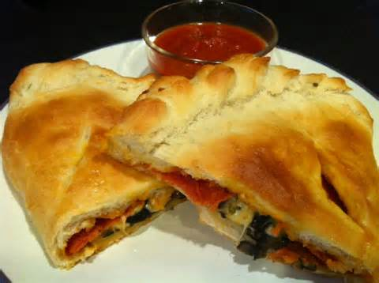

Lab Evaluation
1. How do you stabilize your cutting board?

2. How long should you wash your hands?

3. What is the difference between cleaning and sanitizing?

4. 4 Tbs. = __________ Cup

